# logo

DB-ALM  
Protocol

Template for Data Content

Last Update: September 2013 (v.9.4)



© European Union 2006-2013

http://ecvam-dbalm.jrc.ec.europa.eu

The present template is based on the Content Criteria for Protocols, which are designed for the provision of technical details that enable the documented alternative method to be transferred to other laboratories without the need of additional information.

The Content Criteria, on which the presented template is based, are generic and based on the analysis of common descriptors from hundreds of different non-animal experimental methods and techniques. However, not all parameters or sections indicated are applicable to all protocols. It is the responsibility of the author to provide content where relevant and as appropriate related to a precise protocol. The compilation is to be performed by completing the individual sections with the information related to your method. A review for consistency, completeness in relation to the technique described and compliance with the Content Criteria in place is always performed by the JRC staff. Furthermore, before any protocol is published *via* the DB-ALM, the final draft is reviewed and approved by designated contact person(s) (method’s owner and/or experienced user).

A summary description of the main method features bringing it in a context regarding its intended purpose(s) and application(s), as well as the scientific rationale is always to be provided with each protocol. The content criteria for the method summary will be sent in due course.

The DB-ALM is operated by the European Reference Laboratory for Alternatives to Animal Testing of the Joint Research Centre.

© European Union 2006-2013  
Legal Notice: http://ecvam-dbalm.jrc.ec.europa.eu/

**INDEX**

**Part A. Protocol Introduction 4**

**Résumé 4**

**Experimental Description 4**

**Discussion 4**

**Status 4**

**Proprietary and/or Confidentiality Issues 5**

**Health and Safety Issues 5**

**Abbreviations and Definitions 5**

**Part B. Technical Description 5**

**Contact person 5**

**Materials and Preparations 5**

**Method 6**

**Data Analysis 7**

**Prediction Model 7**

**Annexes 7**

**Bibliography 7**

NOTE: All statements shall be supported with references within the text and full details listed under “**Bibliographic References*”*** data sector.

# Part A. Protocol Introduction

**Protocol Name:** UKN4 assay to test compound-derived impairment in neurite outgrowth in human mature dopaminergic neurons.

**Abstract:** This protocol describes the UKN4 assay to assess cell viability and neurite outgrowth after 24h of compound treatment. It includes information about the differentiation of human dopaminergic neurons.

## Résumé

This assay is based on high-content automated microscopy and images dopaminergic neurons during differentiation (day 3 of differentiation). It assesses not only cell viability (by co-staining with Hoechst and calcein, the latter one being taken up only by viable cells), but also neurite outgrowth. Neurite outgrowth has been shown to be a more sensitive readout than cell viability, enabling to identify substances that specifically impaired neurite area while not affecting cell viability.

## Experimental Description

**Biological Endpoint and Endpoint Measurement:**

Neurite outgrowth is an essential feature for a developing brain to acquire unimpaired function. Impaired development of dopaminergic neurons can be triggered either genetically or by exposure to toxicants and chemicals.

The current protocol is used as an *in vitro* tool to detect compounds that impair neurite outgrowth of developing and differentiating dopaminergic neurons.

The test captures cell viability and neurite area as neuron-specific functional readout after short term exposure to toxicants (24 h).

**Endpoint Value:**

Endpoint values are inhibitory concentrations (IC) and benchmark concentrations (BMC) derived from concentration-response curves of both readouts (viability and neurite area) and the ratio of these.

**Experimental System:**

The human LUnd Human MESencephalic cell line (LUHMES (ATCC® CRL-2927™) is used to generate morphologically and biochemically mature dopamine-like neurons. The differentiating and developing stage of these neurons are then used in the UKN4 assay.

## Discussion

In the UKN4 assay developing human dopaminergic neurons are used. No specific ethical approval is required. Duration of the assay is minimum 3 days due to cell differentiation (2 days) plus treatment period.

Frozen cell batches (each thawed cell batch/vial can be passaged 12-15 times) are not varying much (expression of characteristic genes during differentiation are checked after generating new baches: βIII-tubulin, TH, DAT, DRD2, EN1 and NURR1). The results of one experiment should be normalized with the untreated controls within the same experiment.

The performance of the UKN4 assay requires an automated array microscope (e.g. Cellomics ArrayScanVTI, Thermo Fischer) equipped with a 20x lense. The operator should be trained in good cell culture and good laboratory practice and microscope handling. Otherwise no special handling is required. Operators can get trained within 2-4 weeks. Cell seeding and medium change should be performed as fast as possible to keep cells as short as possible at room temperature. The more practice an operator has, the faster the critical steps can be performed.

To prevent negative edge effects, only the inner 60 wells of a 96-well plate are used and the edge wells should be filled with PBS.

The UKN4 assay is a medium throughput assay. With three technical replicates the results of the assay are reproducible and robust within the lab and trained operators (standard deviation of viability of technical replicates of DMSO controls ~5% of average, standard deviation of neurite area of technical replicates of DMSO controls ~10% of average). Positive hits are meaningful. The ‘negative hits’ provide little information and require other tests in a developmental toxicity test battery. The assay can be combined with other viability assays like ATP quantification or resazurin reduction.

Possible problems: replating the cells at a too high density can then cause problems with cell density later within the assay. Improper coating can result in problems with cell attachment and cell clumping. Also problems with the microscope can affect the efficient performance of the assay, e.g. when autofocus is not working properly.

## Status

**In Development:**

Method is fully developed and established.

**Known Laboratory Use:**

Test system (UKN LUHMES cells) has been transferred and established to numerous other labs. The assay itself has been used only at the University of Konstanz by one operator and hasn’t been transferred or applied in other labs.

Used in EU-ToxRisk (H2020 EU-funded project no No 681002).

**Participation in Evaluation Study:**

Used in EU-ToxRisk project, used in NTP 80 compound library screen.

“Assessment of chemical-induced impairment of human neurite outgrowth by multiparametric live cell imaging in high-density cultures.”

Stiegler NV, Krug AK, Matt F, Leist M.

Toxicol Sci. 2011 May;121(1):73-87. doi: 10.1093/toxsci/kfr034. PMID: 21342877

“Evaluation of a human neurite growth assay as specific screen for developmental neurotoxicants.”

Krug AK, Balmer NV, Matt F, Schönenberger F, Merhof D, Leist M.

Arch Toxicol. 2013 Dec;87(12):2215-31. doi: 10.1007/s00204-013-1072-y. PMID: 23670202

**Participation in Validation Study:**

No participation in a validation study.

**Regulatory Accepted:**

Not submitted to regulatory acceptance.

## Proprietary and/or Confidentiality Issues

No proprietary or confidentiality issues known.

## Health and Safety Issues

**General precautions:**

No safety and health issues known to be related to the method. Risk and Safety Statements of toxicants, compounds and staining dyes should be considered and followed.

**MSDS Information:**

The positive control narciclasine may cause genetic defects.

<https://www.caymanchem.com/msdss/20361m.pdf>

In addition to the safety measures regarding the compounds in use, there are no safety measures needed for the performance of this method.

## Abbreviations and Definitions

BMC: benchmark concentration

DMEM: Dulbecco's Modified Eagle Medium

LUHMES: LUnd Human MESencephalic cell line

N-2: medium supplement by Thermo Fisher Scientific, chemically defined

serum-free supplement based on Bottenstein’s N-1-formula.  
cAMP: cyclic Adenosine MonoPhosphate

GDNF: Glial cell-Derived Neurotrophic Factor

FGF: Fibroblast Growth Factor

IC: inhibitory concentration

PLO: poly-L ornithine

PBS: Phosphate-Buffered Saline

rh: recombinant human

SOP: Standard Operating Procedure

T75: cell culture flask with 75cm2

T175: cell culture flask with 175cm2

FCS: Fetal Calve Serum

HCS: High Content Screening

PD: Parkinson’s Disease

DMSO: Dimethyl sulfoxide

RT: room temperature

T175: cell culture T-flask with a cell attachment area of 175cm2

T75: cell culture T-flask with a cell attachment area of 75cm2

FBS: fetal bovine serum

2D 2-dimensional cell culture

3D 3-dimensional cell culture

MES 2.10: human mesencephalicderived cell line characterized at and originating

from Lund University (Lund, Sweden) (Lotharius et al., 2002).

VCS : viable cellular structures

VCSA : virtual cell soma area

Last Update: March 2018

# Part B. Technical Description

Procedure Details, Latest Version: March 2018

**Protocol Name:**  UKN4 assay to test compound-derived neurite outgrowth impairment in differentiating human dopaminergic neurons.

## Contact person

Prof. Dr. Marcel Leist

In vitro toxicology and biomedicine

Dept inaugurated by the Doerenkamp-Zbinden foundation

University of Konstanz

Box M657

D-78457 Konstanz

marcel.leist@uni-konstanz.de

Tel: +49-7531-88-5037

## Materials and Preparations

**Cell OR Experimental system**

LUHMES cells are the ony test system of this protocol. Cells were originated from the ventral mesencephalon of an 8 week old human, female fetus. They exhibit the same characteristics as MESC2.10 cells (they are a subclone of the tetracycline-controlled, v-myc-overexpressing human mesencephalic-derived cell line MESC2.10).

They can be differentiated into morphologically and biochemically mature dopamine-like neurons following exposure to tetracycline, GDNF (glial cell line-derived neurotrophic factor), and db-cAMP for 6 days.

They are usually cultured in a 2D monolayer, but have also been shown to grow into 3D structures (Smirnova et al. 2015).

Here the LUHMES cells are used for the UKN4 assay to assess the effect of compounds on neurite outgrowth after 24 h of exposure.

**Equipment**

**Fixed Equipment**

Benchtop centrifuge

Laminar flow hood for sterile atmosphere (type II classified)

Liquid nitrogen storage

Freezer (-20°C and -80°C)

Fridge (4°C)

Humified incubator (37°C 5% CO2)

Mr. Frosty™ freezing container

Light microscope for cell counting

Neubauer counting chamber

Pipettes (various volume, 1 µl – 1000 µl)

Pipetboy Pipeteur

Cellomics Array Scan VTI HCS reader

Computers, screens and software for data analysis (e.g. Microsoft Office)

Multichannel pipettes (Integra)

Multistepper pipettes (Eppendorf)

**Consumables**

15 ml and 50 ml conical plastic tubes (such as Falcon™ REF 352096 and REF352070)

175 cm2 cell culture flasks with filtered cap (Sarsted REF 83.3912.002)

96-well plates (Sarsted REF 83.3924)

Deepwell plates (such as Greiner Bio-One REF 786261)

5 ml, 10 ml, 25 ml and 50 ml plastic pipettes (such as Sarsted REF 86.1685.001; REF 86.1689.001; REF 86.1253.001 and REF 12.54.001)

Neubauer counting chamber

Cyrovials (such as Nalgene Cat. No. 5000-0020)

Eppendorf tubes (such as various sizes)

Filter tips (such as Biosphere REF 70.760.212; REF 70.1130.210

Gloves (such as nitrile: VWR Cat. No. 112-2373 or latex: MaiMed REF 74175)

**Media, Reagents, sera, others**

Coating:

Poly-L-ornithine hydrobromide (Sigma-Aldrich; P3655-100mg)

Fibronectin solution (Sigma-Aldrich; F1141-5mg)

Basic medium:

Advanced DMEM/F12 (Gibco™, Thermo Fisher Scientific, Cat. No.12491015)

N-2 supplement (100x ; Thermo Fisher Scientific, Cat. No.17502048)

Glutamine (Sigma-Aldrich, G7513)

Components of Proliferation medium:

rhFGF-2 (R&D Systems; 4114-TC)

Components of Differentiation medium:

Tetracycline (Sigma-Aldrich, T7660-5g)

cAMP (Sigma-Aldrich sodium salt; D0627-1g)

rhGDNF (R&D Systems; 212-GD)

Staining:

Calcein-AM (Sigma-Aldrich; 17783-1MG)

Hoechst Bisbenzimide 33342 (Sigma; 14533-100MG)

other:

Trypsin 0,05% (ThermoFisher Scientific; 25300-062)

PBS without Ca2+/Mg2+ (Biochrom AG L1825)

DMSO (Sigma D2650)

FBS (PAA A15-101)

**PREPARATIONS**

**Media and Endpoint Assay Solutions**

Freezing medium:

Advanced DMEM/F12

FBS to a final concentration of 20 %

DMSO to final concentration of 10 %

The freezing medium is always prepared freshly prior to use. No information about stability can be stated. Prepare under sterile conditions.

Aliquots of reagents:

Poly-L ornithine (PLO) (1mg/ml):

dissolve 100 mg in 100 ml of sterile distilled water

filter sterile (using filter pore of 0.22 µm)

aliquots of 5-10 ml, aliquotting under sterile conditions

store at -20°C

Can be stored up to 3 months. After thawing the solution is stored at 4°C till use and not re-frozen.

Fibronectin (1mg/ml):

aliquots of 150 µl, aliquotting under sterile conditions

store at 4°C

Can be stored up to 3 months. Do not freeze.

N-2:

ready to use

store at -20°C

Stable till use-by date of provider. As one vial is enough for one bottle of medium it is used after thawing and never re-frozen again. However re-thawing and re-freezing is possible up to 10 times.

L-Glutamin (200mM):

thaw in water bath, mix thorougly

aliquots of 10 ml, aliquotting under sterile conditions

store at -20°C

After thawing, L-Glutamin can be re-frozen and re-thawn one more time.

Fibroblast Growth Factor rhFGF-2 (160µg/ml):

prepare 0.1% (m/v) BSA in PBS

sterile filter (using filter pore of 0.22 µm)

dissolve 1 mg FGF in 6.25 ml of sterile 0.1% BSA/PBS

aliquots of 100 µl, aliquotting under sterile conditions

store at -20°C

Glial cell-Derived Neurotrophic Factor (rhGDNF) (20µg/ml):

dissolve in 0.1% (m/m) BSA in PBS and sterile filter (using filter pore of 0.22 µm)

stocks 1 ml (store at -80°C)

aliquots of 20 µl, aliquotting under sterile conditions

store aliquots at -20°C

Can be re-frozen and re-thawn. Stable up to 3 months.

Tetracyclin (1mg/ml):

weigh 25 mg and dissolve in 25 ml sterile distilled water

sterile filter (using filter pore of 0.22 µm)

aliquots of 500 µl, aliquotting under sterile conditions

store at -20°C

Can be re-frozen and re-thawn. Stable up to 3 months.

cAMP (100mM):

dissolve 1g in 20,4 ml of sterile distilled water

sterile filter (using filter pore of 0.22 µm)

1 ml aliquots in brown Eppis, as cAMP is light sensitive

store at -20°C

Can be re-frozen and re-thawn. Stable up to 3 months.

0.05% Trypsin:

thaw in water bath

aliquots of 12 ml, aliquotting under sterile conditions

store at -20°C

After thawing trypsin can be stored at 4°C till aliquot is finished. No re-freezing and re-thawing when aliquot is in use. Aliquots at -20°C are stable up to 3 months.

Coating solution:

|  |  |
| --- | --- |
| **Components of medium** | **Volume required per 1 ml** |
| Sterile MilliQ H2O | 955 µl |
| Polyornithin (1 mg/ml in water) | 44 µl |
| Fibronectin (1 mg/ml in water) | 1 µl |

Prepare freshly and use immediately.

Proliferation medium:

|  |  |
| --- | --- |
| Components of medium | Volume required per 10 ml |
| Advanced DMEM/F12 | 9.8 ml |
| L-Glutamine (200mM) | 100 µl |
| N2 (100x) | 100 µl |
| FGF-2 (160µg/ml) | 2.5 µl |

Prepare freshly and use immediately.

Differentiation medium:

|  |  |
| --- | --- |
| Components of medium | Volume required per 10 ml |
| DMEM/F12 Advanced | 9.7 ml |
| L-Glutamine (200mM) | 100 µl |
| N2 (100x) | 100 µl |
| cAMP (100mM) | 100 µl |
| Tetracycline (1 mg/ml) | 10 µl |
| GDNF (20 µg/ml) | 1 µl |

Prepare freshly and use immediately.

Staining solution

* for 96-well plates 10 µl per well; staining solution: 10 µM calcein-AM and 10 µg/ml Hoechst 33342 dyes in PBS. Calcein-AM stock solution is 4 mM in DMSO (-> dilute calcein stock solution 1:400) and Hoechst stock solution is 1 mg/ml in MilliQ water (-> dilute Hoechst stock solution 1:100).
* Prepare freshly and use immediately. No long-term storage.

**Test Compounds**

Test compound are stored according to manufacturer’s instructions. Stock solutions should be dissolved in sterile water or DMSO, if possible 1000x more concentrated than the working solution. The used DMSO is stored in a lightproof, air-tight bottle at room temperature.

The stock solutions are aliquoted into volumes sufficient for one experiment and frozen at -80°C. The aliquots are only used once and discarded after first thawing. This avoids repeated freezing and thawing and therefore to damage the compounds stability and efficiency. At 80°C the compound aliquots are considered to be stable for several months.

Compound dilutions are usually prepared in steps of 1:3, but the ratio can be increased up to 1:1.5 if needed. The dilutions are prepared in deep well plates using medium containing 1% DMSO (as the addition of 10 µl to 90 µl results in a 1:10 dilution, the final concentration of DMSO on the cells is 0.1%).

**Positive Control(s)**

Positive control is Narciclasine, which reduced neurite area to 50% of DMSO control, while cell viability was reduced only by 10% (50 nM final concentration). The Narciclasine preparation follows the same indications as for the test compound: stock solution in DMSO (50 µM), aliquots of 10 µl, storage at -80°C, discarding after use, no re-freezing and re-thawing.

**Negative Control(s)**

Negative control is 0.1% DMSO final concentration.

## Method

**EXperimental System Procurement**

Storage of cells

Frozen cell batches are stored in liquid nitrogen.

Thawing of cells

Prepare and pre-warm proliferation medium. Prepare a falcon with 9 ml of Advanced DMEM/F12 medium without supplements. Take a LUHMES cell vial out of liquid nitrogen and thaw at 37°C in the water bath until almost completely unfrozen. In sterile conditions, quickly transfer the cell suspension to the falcon with medium without supplements to dilute the DMSO. Centrifuge (5min at 300g) to get rid of the freezing medium. Aspirate the medium, resuspend the cells in 1 ml of pre-heated proliferation medium and seed them in a pre-coated T75 flask with 14 ml proliferation medium, so that the total volume is 15 ml.

**Routine Procedures**

Coating

LUHMES cells only grow on coated plastic ware.

The coating solution is added in the following volumes to flasks and plates:

10 ml per T75 flask

20 ml per T175 flask

50 µl/well in 96 well plate

and incubated overnight at 37°C and 5% CO2 in the incubator. The next day the coating solution is aspirated and washed once with sterile MilliQ water (10 ml per T75 flask, 20 ml per T175 flask, and 100 µl/well in 96 well plate) to remove potential leftovers.

Cell passaging

• For maintenance, grow LUHMES cells in flasks

• At 60-80% of confluency, aspirate medium and wash once gently with pre-warmed PBS (37°C)

• Add 2 ml of pre-warmed (37°C) trypsin (T0.05%) to a T75 flask, 4ml to a T175 flask

• Incubate shortly 2-3 min at 37 °C untill the cells detach. Rigorous tapping to the flask speeds up the detachment (hold flask with one hand, keep it planar, harshly tap against the flask with the other hand).

• Add Advanced DMEM/F12 without supplements to the flask (18 ml for T75 flasks or 36ml for T175 flasks) and resuspend cells by pipetting vigorously up and down several times to obtain a single cell suspension

• Transfer cell suspension into 50 ml Falcon tube

• Centrifuge at 300g at room temperature for 5 min

• Discard supernatant carefully and resuspend pellet in an appropriate volume of medium (estimated cell number should be 5-10 million cells / ml) and count living cells in a Neubauer chamber.

• Plate 2 x106 cells per T75 in 20 ml of proliferation medium and let the cells grow for 2 days in an incubator at 37°C, 5% CO2.

Freezing of cells

For preparation pre-cool Mr. Frosty containers at -20°C. Label cryotubes with ethanol-proof pen. These procedure should be done when the LUHMES cells are at approx. 75% confluency.

Wash with PBS and then detach cells with trypsin as described previously. After resuspension in 18 ml Advanced DMEM / F12 without supplements, determine cell number by counting with a Neubauer chamber. Cell number is determined before centrifugation, as cells cannot last in freezing medium. The amount of cells lost in the centrifugation process is neglectable. Centrifuge the cell suspension to get rid of old medium and trypsin. Resuspend cells in an appropriate volume of cold freezing medium to obtain a suspension of 3-5*106 cells/ml and quickly distribute through pre-labelled cryovials. Put cryovials to pre-cooled Mr. Frosties and freeze at -80°C for at least 3h (better overnight). Transfer the vials to liquid nitrogen.

**Test Material Exposure Procedures**

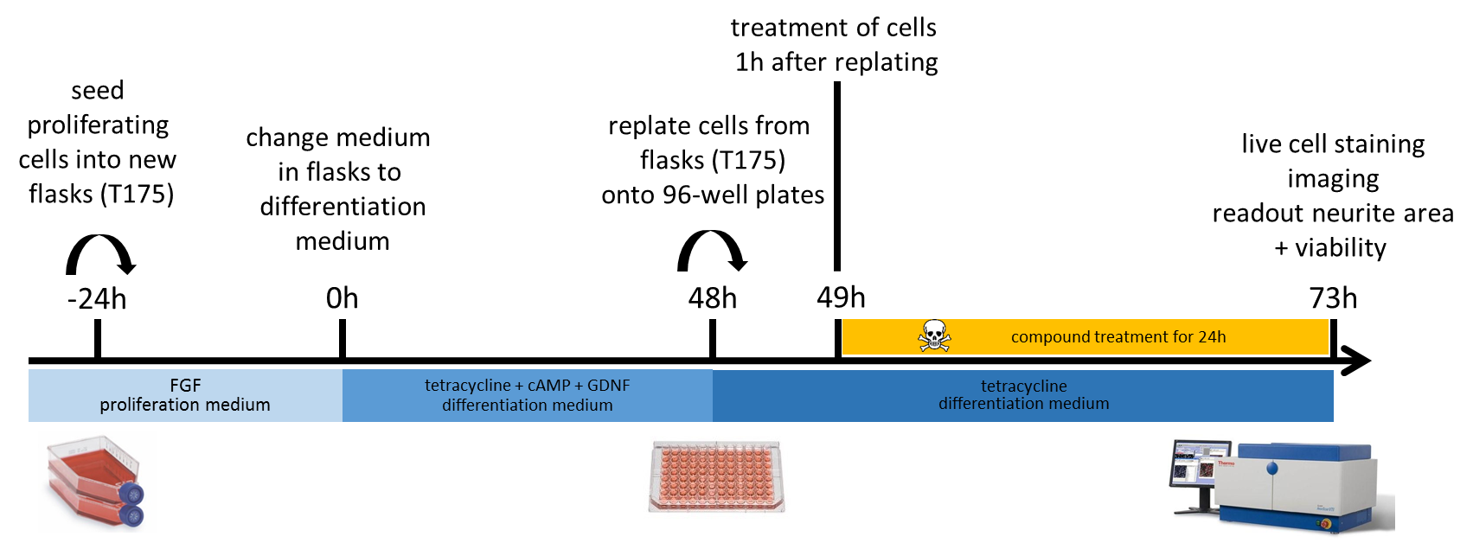

*Fig. 1:* exposure scheme for UKN4. Medium supplements are indicated in blue underneath arrow. Compound exposure is highlighted in yellow.

The following steps are conducted subsequently:

-24h: pre-differentiation:

To expand cells before differentiation is started, 7*10^6 cells per T175 flask are seeded in 20 ml proliferation medium. One T175 flask with 7*10^6 cells will result in 30*10^6 cells on d2 (48h in Fig. 1) of differentiation, so depending on cell number needed on d2 (48h in Fig. 1), (replating to 96-well plates), several flasks need to be seeded.

0h: start of differentiation:

To start differentiation, the cells are either seeded directly into differentiation medium (20*10^6 cells in T175), or the medium in the flasks seeded on d-1 (-24h in Fig. 1) is changed to differentiation medium without detaching or re-seeding cells.

48h: seeding in 96-well plates on day 2 of differentiation:

The cell amount per T175 flask should be around 30-40*10^6, equivalent to 75-80% confluency. Cells are trypsinized and resuspend in a concentration of 30.000 cells/ml. Distribute 90µl/well.

49h: treatment with toxicant:

On day 2 of differentiation, 1 h after seeding to 96 well plates, the compounds are added (in 10µl of volume). The cells are exposed to the toxicant for exactly 24 h (toxicant treatment and staining) from day 2 to day 3 of differentiation.

Typical 96-well plate layout:

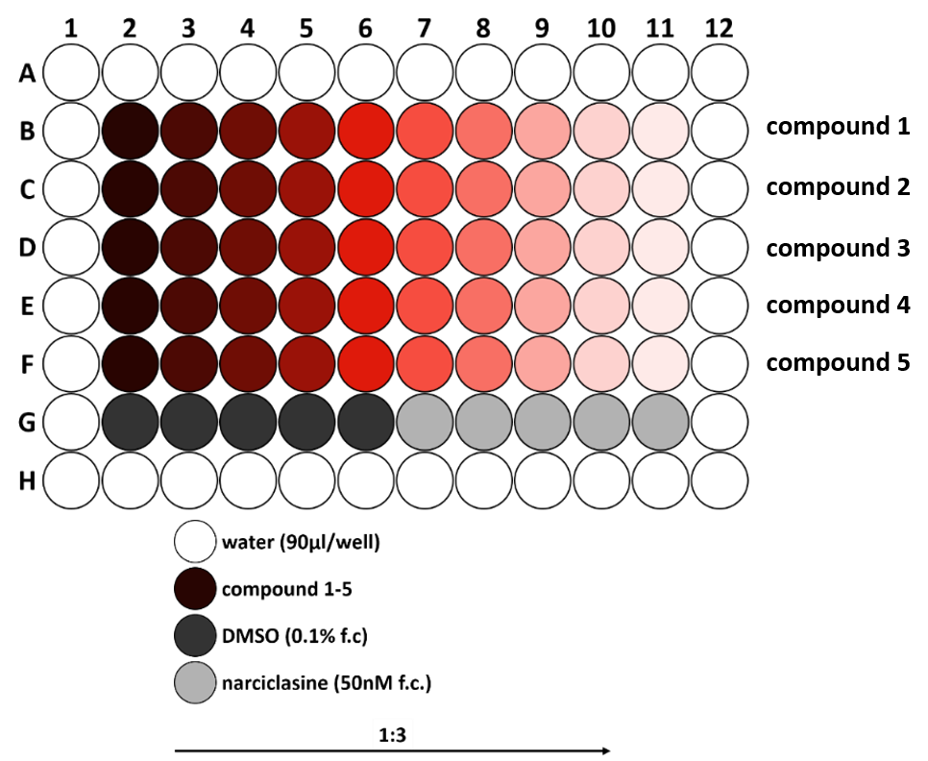

*Fig. 2:* recommended plate layout of UKN4 assay. Dilution series from left to right, with highest concentration of the left, lowest concentration on the right. Red colour indicates compound, the colour getting lighter and lighter represents the increasing dilution. Dark grey is the negative solvent control (DMSO 0.1% final concentration), light grey is positive control (Narciclasine 50 nM final concentration). Due to evaporation effects the outer wells are not used for the assay and only filled with water.

d6: staining and readout:

23.5 h after exposure (on day 6 of differentiation) cells should incubate with the staining solution at 37°C and 5% CO2 in the incubator for at least 30min before imaging. Once stained, the staining remains stable up to 2 h. 10 µl of staining solution are added to each well. The readout using the automated microscope is done ideally exactly 24 h after compound treatment.

**Endpoint Measurement**

There are two endpoints measured in the UKN3b assay (viability and neurite area) both based on the fluorescent readout of the staining solution, using a fluorescent microscope (Cellomics ArrayScan VTI HCS microscope).

To measure viability and neurite area, the cells are stained 0.5 h before imaging. After staining the cells are incubated at 37°C and 5% CO2 in the incubator until imaging. The cell staining is imaged in a Cellomics Array Scan VTI HCS reader automated microscope. Hoechst H-33342 staining is imaged in channel 1 (UV-Hoechst); calcein staining is imaged in channel 2 (Green-FITC). Exposure times are set manually to enable ideal quality for the image analysis algorithms (depending on incubation time with staining in our hands ~1-4 msec). While images in channel 1 (Hoechst) are exposed within the range (no overexposure), images acquired in channel 2 (calcein) are on the limit to overexposure. See Fig. 3, left, upper row for example images.

Quantification of cell viability and neurite area are performed using the Cellomics Scan software (Insight version 1.6.2.4 – 1.00 x (Build 6390); Thermo Fisher Scientific).

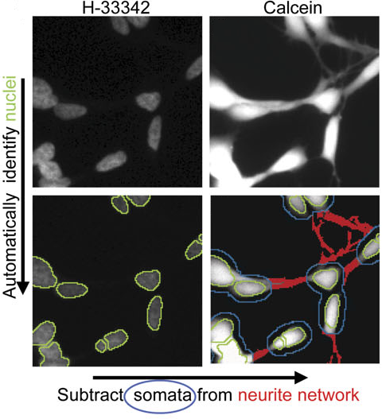 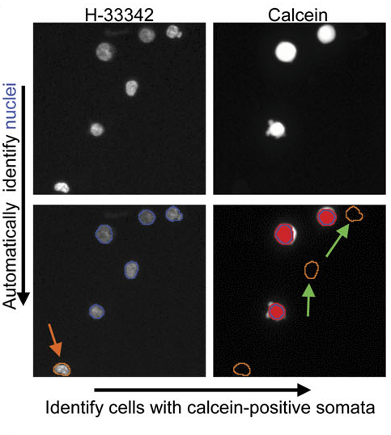

*Fig. 3:* example images of algorithm quantifying neurite area and viable cells. Left side: quantification of neurite area. Right side: Quantification of viable cells. Details in text below.

Quantification of neurite outgrowth (Fig. 3, left)

* For image acquisition, an **automated microplate reading microscope** (such as Array-ScanII HCS Reader, Cellomics, PA) equipped with a Hamamatsu ORCA-ER camera (resolution 1024 x 1024; run at 2 x 2 binning) should be used.
* Ten fields per well are imaged. Images are recorded in **2 channels** using a 20x objective and excitation/emission wavelengths of 365 ± 50/535 nm ± 45 nm to detect H-33342 in channel 1 and 474 ± 40/535 nm ± 45 nm to detect calcein in channel 2.
* In both channels, a fixed **exposure time** and an intensity histogram-derived threshold are used for object identification.
* Neurite pixels are identified using the following image analysis algorithm: nuclei are identified as objects in channel 1 according to their size, area, shape, and intensity which are predefined on untreated cells using a machine-based learning algorithm, and manual selection of nuclei to be classified as intact. The nuclear outlines are expanded by 3.2 µm in each direction, to define a virtual cell soma area (VCSA). based on the following procedure: The average width of the cytoplasm ring (distance nucleus - cell membrane) of LUHMES cells was experimentally determined to be 2.3 µm. Size irregularities are not always due to growing neurites, as determined by combined F-actin/tubulin beta-III staining. To avoid scoring of false positive neurite areas, the exclusion ring (VCSA) is made bigger than the average cell size. We found 3.2 µm to be optimal both to detect neurite growth over time and to identify reduced neurite growth with high sensitivity.
* All calcein-positive pixels of the field (beyond a given intensity threshold) are defined as viable cellular structures (VCSs). The threshold is dynamically determined for each field after flat field and background correction and intensity normalization to 512 gray values and is set to 12% of the maximal brightness (channel 63 of 512).
* The VCS defines the sum of all somata and neurites without their assignment to individual cells. In an automatic calculation, the VCSAs, defined in the H-33342 channel, are used as filter in the calcein channel and subtracted from the VCS. The remaining pixels (VCS - VCSA) in the calcein channel are defined as neurite area.

Quantification of individual viable cells by imaging (Fig. 3, right)

* For a quantitative assessment of viable cells, the same images used to assess neurite area are analyzed using another image analysis algorithm: nuclei are identified in channel 1 as objects according to their size, area, shape, and intensity. Nuclei of apoptotic cells with increased fluorescence are excluded.
* A virtual cell soma area (VCSA) is defined around each nucleus by expanding it by 0.3 µm into each direction.
* Calcein-AM staining, labeling live cells, is detected in channel 2. The algorithm quantifies the calcein intensity in the VCSA areas. Cells having an average calcein signal intensity in the VCSAs below a predefined threshold are classified by the program as “not viable”. Valid nuclei with a positive calcein signal in their cognate VCSA are counted as viable cells.

**ACCEPTANCE CRITERIA**

Positive control narciclasine:

Neurite area ≤ 75% of DMSO control

Viability ≥ 90% of DMSO control (or not significantly changed)

Negative control DMSO:

Neurite area ≥ 35.000

## Data Analysis

- Array Scan VTI HCS Reader (Cellomics, PA) takes images (optionally bitmap or tiff-format; 512 x 512 pixels, 8bit or 16bit)

- Images are locally analyzed using the Array Scan software, algorithms quantify neurite area and cell count (nuclei)

- data are copy-pasted into an Excel sheet (see Figure 4), further analysis is done with Excel + KNIME + GraphPad Prism

- The data are analyzed and represented with GraphPad Prism.

- For the concentration curve, a nonlinear regression fit is calculated. The fitting method is least squares. If a non-linear curve fit is not possible, a linear curve fit is performed. The curve deriving from the fit is a 4-parameter log function.

- To calculate the EC50 value, this log-function is solved for y=50% of the total scale, not for 50% of the min-max scale.

- Treated concentrations are analyzed for deviation from control. Sometimes it is analyzed whether the deviation of neurite growth is different from the deviation of viability. This is done by two-way ANOVA + Tukey-Kramer post hoc testing.

- Statistics applied are one-way ANOVA (and nonparametric) with Dunnett’s post test.

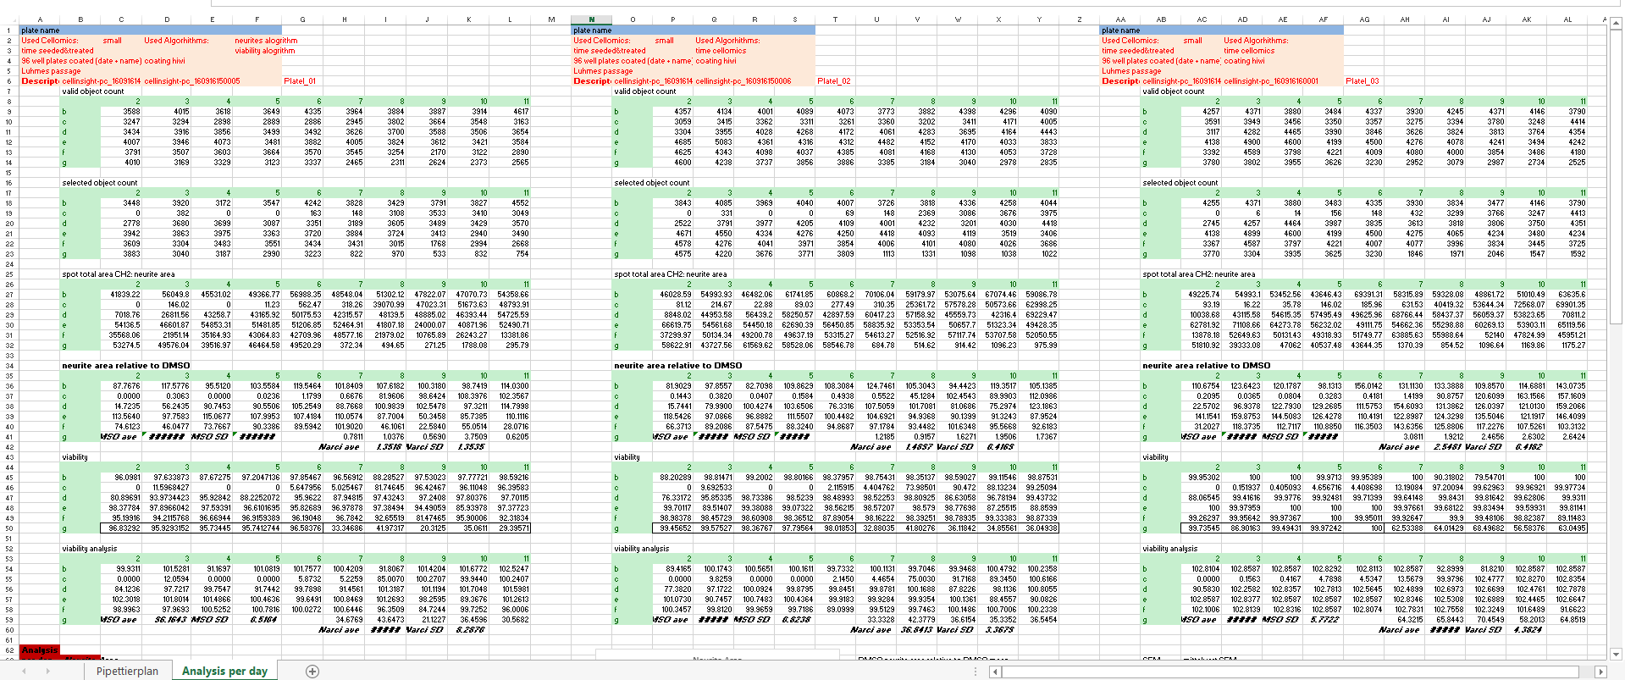

*Fig. 4:* screenshot of an Excel sheet used for analysis. Each column represents one plate, e.g. one technical replicate. The different readouts (neurite area, cell nuclei, viable cells) are listed underneath each other. Percentage of viable cells and normalization to DMSO control are calculated in this Excel sheet.

## Prediction Model

Two different models are used:

1. prediction model for screening:

hit = decrease/increase in neurite area while viability is not changed (compare to narciclasine positive control:

Neurite area ≤ 75% of DMSO control

Viability ≥ 90% of DMSO control

2. prediction model for compound hazard evalaution:

hit confirmation testing;

EC50 Viability (V) / Neurite Area (NA) ≥ 4 → specifically neurotoxic

## Annexes

No annexes available.

## Bibliography

“Rapid, complete and large-scale generation of post-mitotic neurons from the human LUHMES cell line.”

Scholz D, Pöltl D, Genewsky A, Weng M, Waldmann T, Schildknecht S, Leist M.

J Neurochem. 2011 Dec;119(5):957-71. doi: 10.1111/j.1471-4159.2011.07255.x. PMID: 21434924

“Assessment of chemical-induced impairment of human neurite outgrowth by multiparametric live cell imaging in high-density cultures.”

Stiegler NV, Krug AK, Matt F, Leist M.

Toxicol Sci. 2011 May;121(1):73-87. doi: 10.1093/toxsci/kfr034. PMID: 21342877

“Evaluation of a human neurite growth assay as specific screen for developmental neurotoxicants.”

Krug AK, Balmer NV, Matt F, Schönenberger F, Merhof D, Leist M.

Arch Toxicol. 2013 Dec;87(12):2215-31. doi: 10.1007/s00204-013-1072-y. PMID: 23670202

“A LUHMES 3D dopaminergic neuronal model for neurotoxicity testing allowing long-term exposure and cellular resilience analysis.”

Smirnova L, Harris G, Delp J, Valadares M, Pamies D, Hogberg HT, Waldmann T, Leist M, Hartung T.

Arch Toxicol. 2016 Nov;90(11):2725-2743. Epub 2015 Dec 8. doi: 10.1007/s00204-015-1637-z. PMID: 26647301